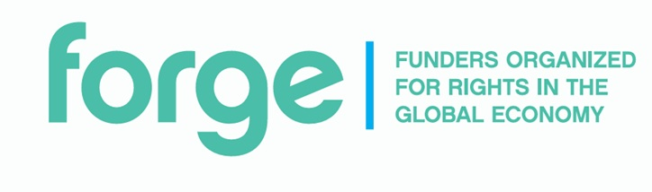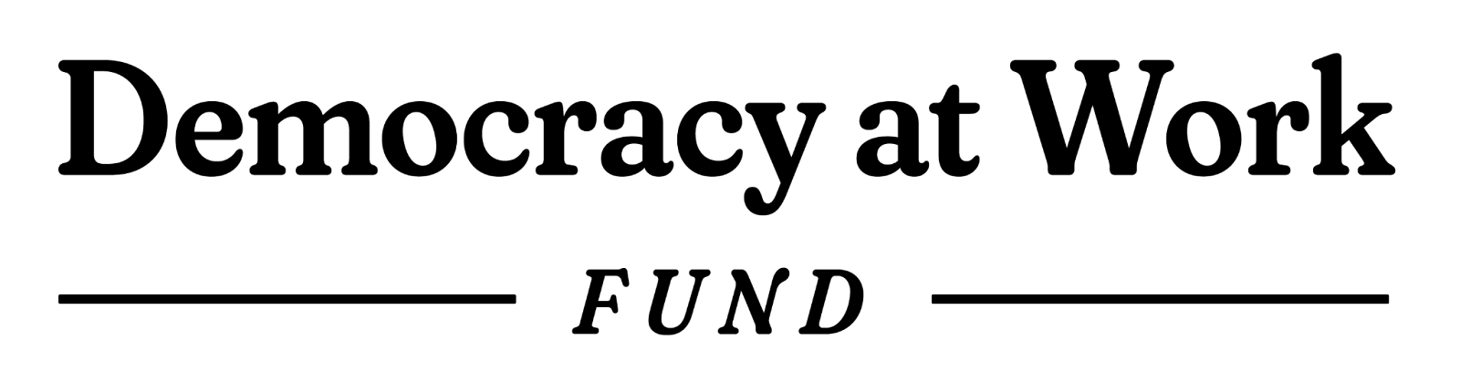

The Democracy at Work Fund 2025/2026

Application Form Questions
The Democracy at Work Fund pools support from multiple funders to deliver grants to frontline organizations in Asia, Africa, and South America aimed at building resilience and strengthening the capacity of workers’ organizations. Initiatives from Bangladesh, Indonesia, Kenya, South Africa, Argentina and Brazil are eligible to apply to this year’s fund. The Fund prioritizes efforts led directly by informal workers, led by women and underrepresented groups, as well as efforts at the intersection of workers’ rights, gender justice, racial justice, and climate justice.
Work in the following interconnected areas will be supported:
- Worker organizing with a specific focus on unrepresented or under represented groups
- Efforts by worker organizations to increase strength and influence
- Organizing to address major crises and transitions
Please review full application guidelines here prior to completing this form.

Section A: Organizational Profile

- Organization/s Name
(Optional: please also link to your organizational website if available)

- Organizational Profile (Lead partner)  (Select ALL that apply) | ☐ Community-Based Organization  ​☐ Social Movement  ​☐ Network or Coalition  ​☐ Trade Union/ Worker Collective  ​☐ Civil Society Organization (CSO)  ☐ Other
- Duration of Operations  How many years has your organization been operating? | ☐ Less than 2 years  ☐ 2-5 years  ☐ 5 years or more
- Geographic Scope:  (Select one or more) | ​☐ Argentina  ☐ Bangladesh  ☐ Brazil  ☐ Indonesia  ☐ Kenya  ☐ South Africa  ☐ Working globally  ​☐ Working regionally  ​☐ Working nationally  ☐ Working locally
- Organizational Leadership  (Select one or more) | ☐ The organization is led directly by workers (e.g., trade unions, worker collectives, or groups engaged in labor organizing, collective bargaining, advocacy, or movement-building)  ☐ This organization is women-led  ☐ This organization is led by an under-represented or marginalized group (please specify: _________)  ☐ This organization has democratically-elected leadership structures  ☐ This organization has dues-paying membership
6. Decision-making
How does your organization make decisions, and who participates? If you have formal processes (like elections, general assemblies, or leadership boards), please describe them. If your structure is more informal, please share how decisions are made in practice. (Maximum 200 words)
7. Partner Communities
Does your organization work with or hope to work with people and communities that experience marginalization/exploitation and/or exclusion? For example, but not limited to: women, LGBTQI+, people with disabilities, racialized or migrant communities. Please share details. (Maximum 150 words)
8. Workers Represented
What number of workers are represented by your entity? Feel free to share more about the context or sector you are active in (such as the sector, type of work, or location) to help us understand this number. (Maximum 150 words)
9. Long-term Goals & Targets
What are your organization’s long-term goals and targets? Please provide specifics where possible. (Maximum 200 words).
10. Annual Budget & Donors.
What is your annual budget in the current financial year? Please list your main donors/ sources of income in $US.
11.Track Record
What is your organization’s track record and key accomplishments to date? Please include any experience you have in worker organizing, negotiation and collective bargaining. (Maximum 600 words)
12. Team Members
Who are the key team people leading or coordinating this initiative (for example, staff, elected leaders, core organizers, or worker representatives)? Please share their roles and any relevant experience that helps them carry out this work (Maximum 300 words)
13. External Partners
Who are the partners your organization collaborates most closely with? How do you work together? (These can include networks you are a part of, peer organizations or others in your network) (Maximum 300 words)

Section B: Initiative Details

- Problem
What problem are you seeking to address? (Maximum 250 words)
- Target Group
What target group or communities are you seeking to support? How many? How are you planning to support them? (Maximum 200 words)
- Activities
What are your proposed activities? (Maximum 400 words)
- Impact
What impact do you hope to see as a result of this project? (Maximum 300 words)
- Project Partners
Are you working with other organizations/ communities and/or movements to deliver this work? If so, please provide details. (Maximum 150 words)
- Risk Mitigation
What risks or challenges do you anticipate could interfere with the progress of the initiative? These may include, political, safety, economic etc. How are you proposing to mitigate them? (Maximum 300 words)

References

References: Please provide contact details (name, job title, organization, phone, email) for at least two referees in the labor/gender/climate or human rights community who know about and can comment on your work. These should be external to your organization. At least one referee should be a previous funder of your work (this can also be a subgranter rather than a direct granter where relevant)
Additional
Is there any other context that you’d like to share that may support your application? (Optional) (Maximum 150 words)

For a breakdown of definitions around informal workers and the informal economy see: https://www.wiego.org/informal-economy/faqs/
A subgrantor receives grant funds from a primary funder (the donor or grantor) and then re-awards part of those funds to another organization

